Weekly Report Out 6

Team: Drone Link

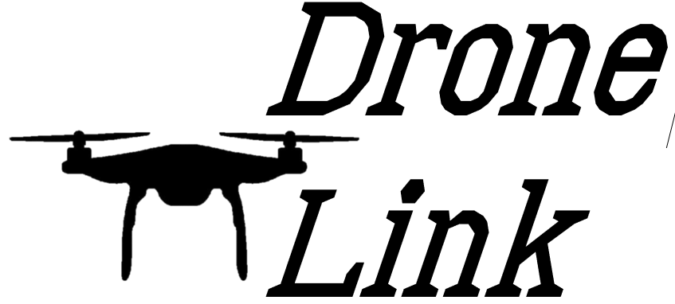Sam Forest, Alex Holt, Vincent Krenz, Lucas Larocco, Blake Masbruch

10/23/2020

Senior Design Adviser: Professor Wiedenhoeft

ScrumMaster: Vincent Krenz

Current Cadence: 3

**Progress**

We have spent the first week of cadence 3 grooming the backlog and reviewing our development strategies. We decided to regroup before this longer 3-week cadence to make sure we get into development efficiently ad set ourselves up for success in the next two quarters as well. This step back should improve our efficiency in the weeks to come and allowed the team to clear their heads from any lingering midterm anxiety. We also started development on the database side with rethinkDB, timer setup screen, timer mockup, creating dataflow diagrams for timer, and process improvements.

**Future Progress**

We plan on finishing all mockups and process improvements to be able to dive into the development work and begin laying the groundwork for a successful product. This development cadence will be the real start of our project and we are looking forward to making some highly visible progress on our overall goals.

**Reflection**

We are using this longer cadence to make a well-defined methodology for developmental progress and getting the team back into the swing of continuous work. With midterms over the team can focus on work before preparing for finals, which should lead to a productive cadence.